Business Plan Template

for ABC

(Downloadable Template)
by

How to Use This Template
This business plan template contains visual templates for each section of a business plan. You can change the order, remove the elements that doesn’t fit your requirements and modify the template before presentation.

How to Use the Diagrams
The diagram examples provided are editable. Use the link provided with them to open them in the Creately editor and modify them as suits your needs. Once opened in the editor you can change colors, styles, fonts, images etc. and export them as images or PDFs.

Executive Summary

Startup Business
<If your business is a startup, the main purpose of your business plan is to secure funds from investors. Therefore, your executive summary should summarize:

- Business opportunity
- Business model
- Target market
- Competition
- Marketing and sales strategy
- Operational plan
- Owners and managements
- Financial analysis >

Established Business

<If your business is already well-established, your business plan should include synopses of;

- Mission statement
- Brief description of your company (history/ owners/ number of employees/ location detail etc. )
- Major milestones
- Financial summary
- Future objectives >

Company Profile
<Your company profile should provide details on
- Company history
- Overview of the company
- Mission Statement
- Key resources
- Business contact information
- Products or services
- Location details
- The market you serve
- Your key customers
- The customer issue you seek to solve>

*Use the following infographic to present these elements in your company profile.
http://creately.com/creately-start?tempID=js45vqaq1

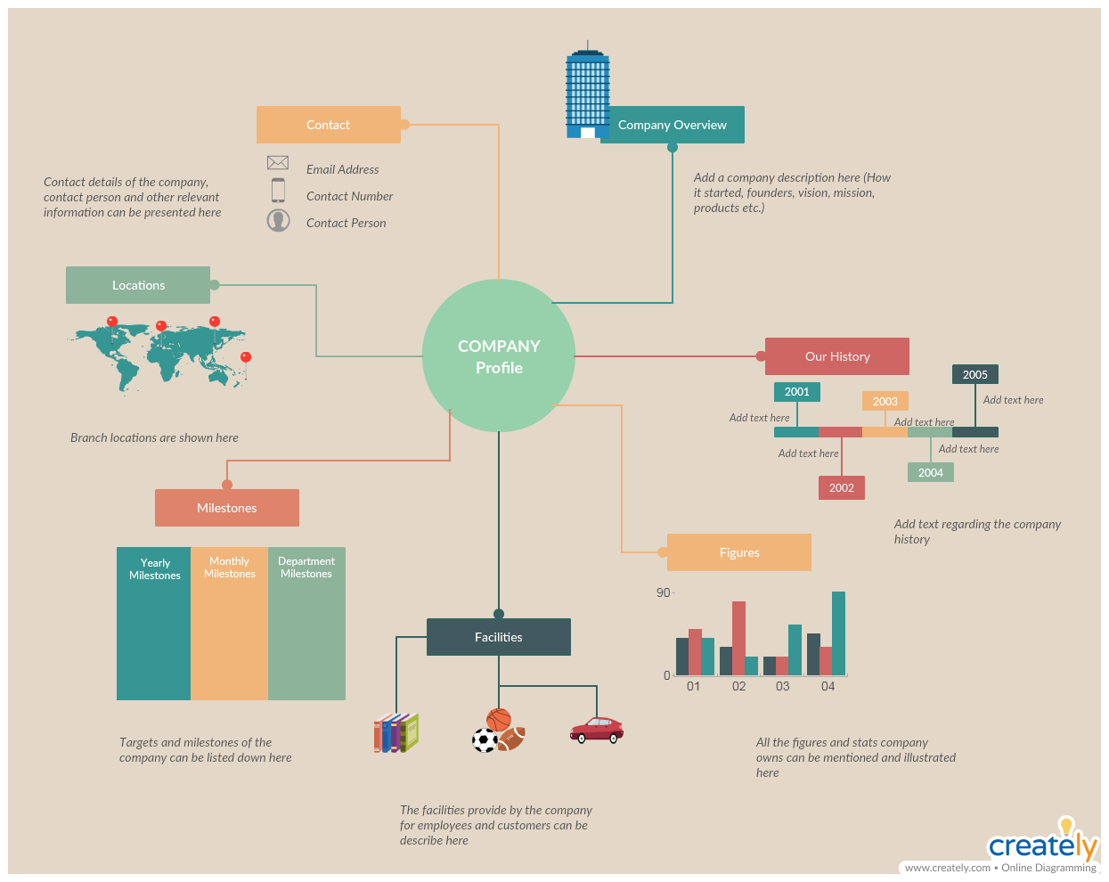

Market Analysis
<This section should include the conclusions of the data you have gathered through a market analysis.>

* Summarize the survey data on your customers with the help of this customer profile
http://creately.com/creately-start?tempID=js4727vl1
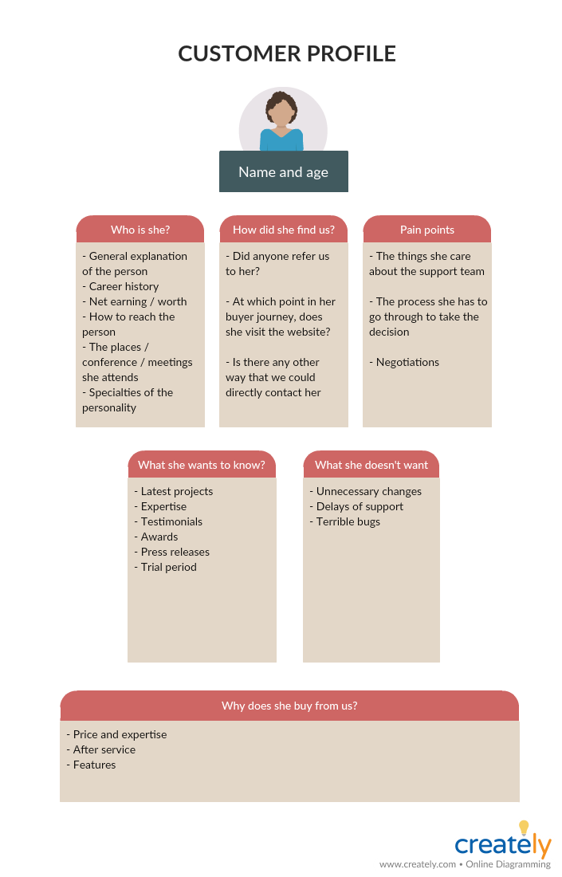

* Present how your potential or existing customers perceives the brands/ product/ services of your competitors in the market
http://creately.com/creately-start?tempID=js47gklt1

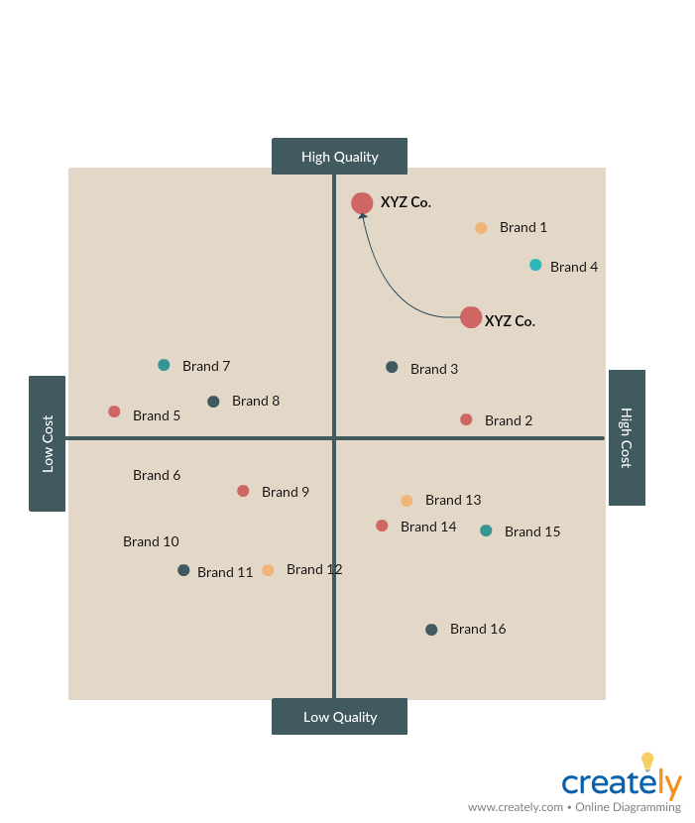

* Portray your company’s strength and position against your competitors with this Porter’s five forces template
http://creately.com/creately-start?tempID=js48e8yn1

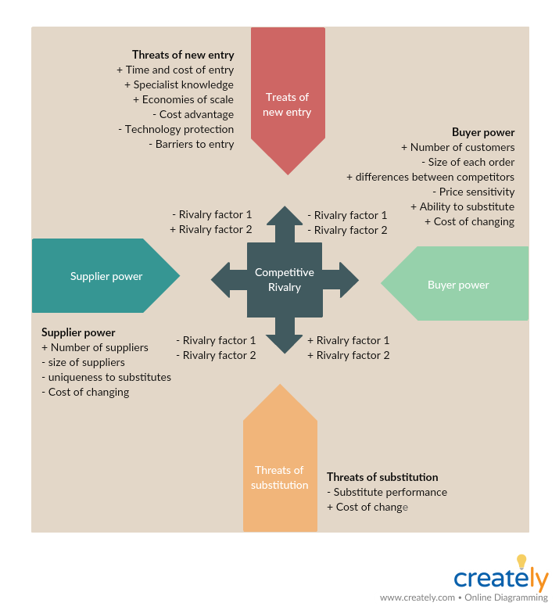

* Discuss the strengths and weaknesses of your competitors and opportunities and threats they bring to your company with this SWOT analysis template
http://creately.com/creately-start?tempID=js48uduc1
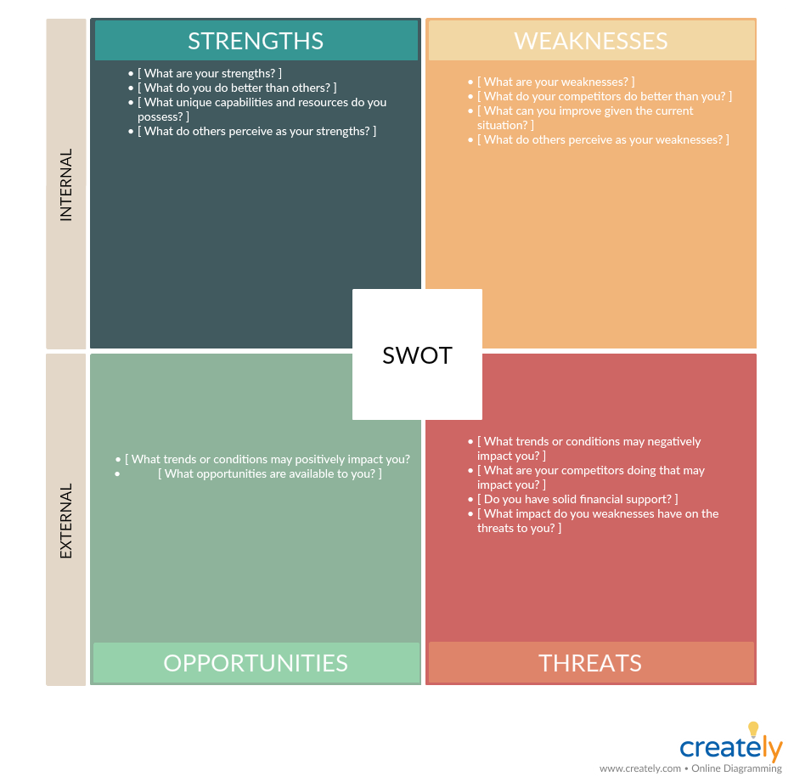

* Analyze the Political, Economical, Socio-Cultural and Technological in your market is affecting your company and it’s growth with this PEST analysis template.
http://creately.com/creately-start?tempID=gsx1cnem5

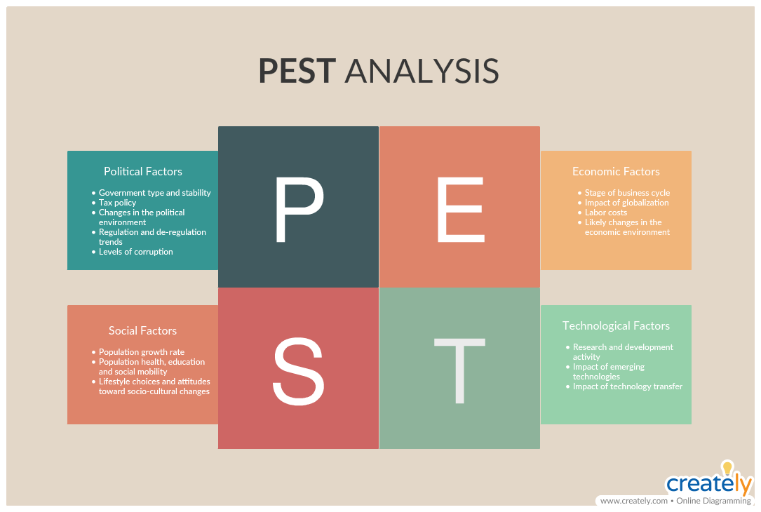

* Present the data you have gathered on your competitors more effectively and in a reader-friendly way with this competitor profile.
http://creately.com/creately-start?tempID=js4c3xzy1

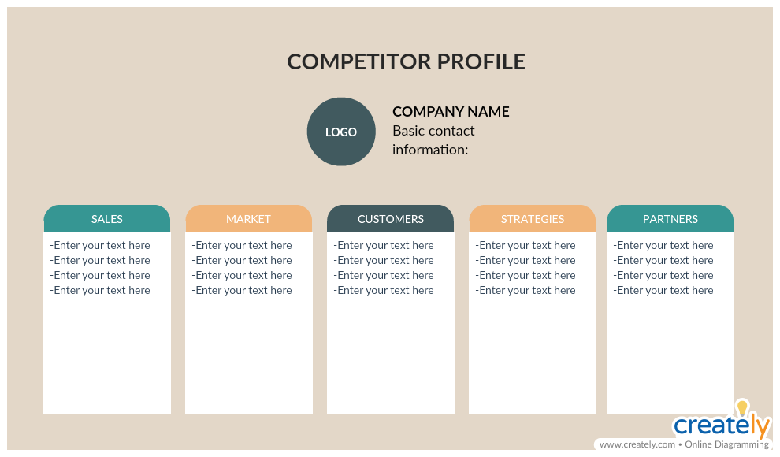

* Or you can use this competitor intelligence mind map to organize and present your research data.
http://creately.com/creately-start?tempID=js4cjkio1

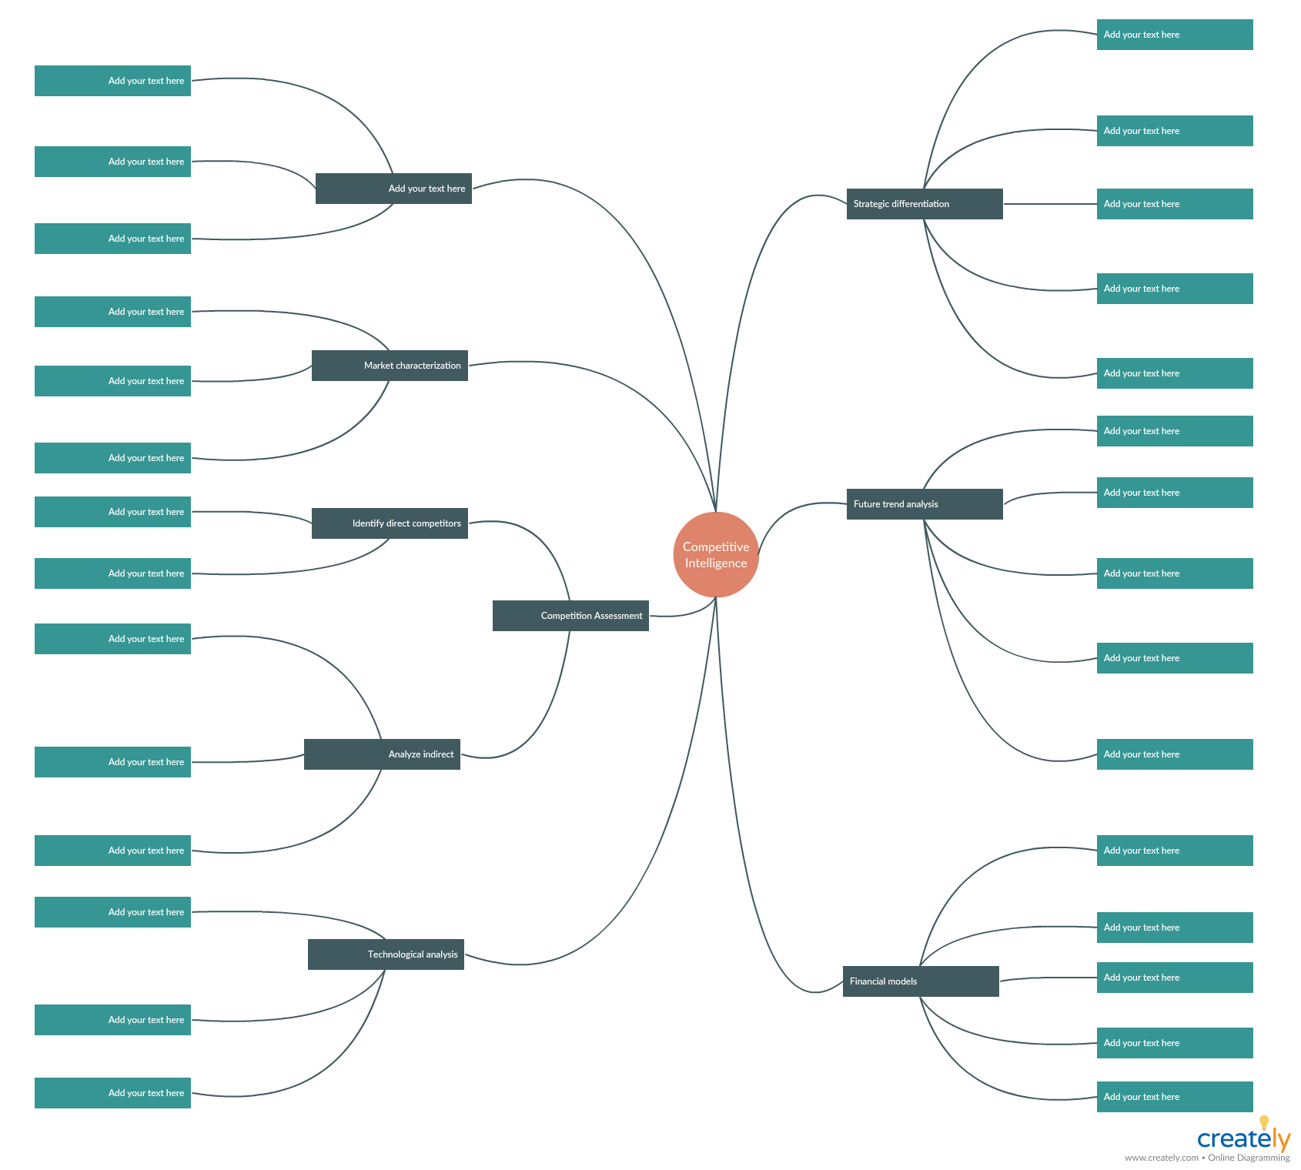

Marketing and Sales Strategies
<Outline how you plan to market and sell your product or service to your customer. You can do this quickly with mind maps>

* Marketing plan template
http://creately.com/creately-start?tempID=js9sbn532
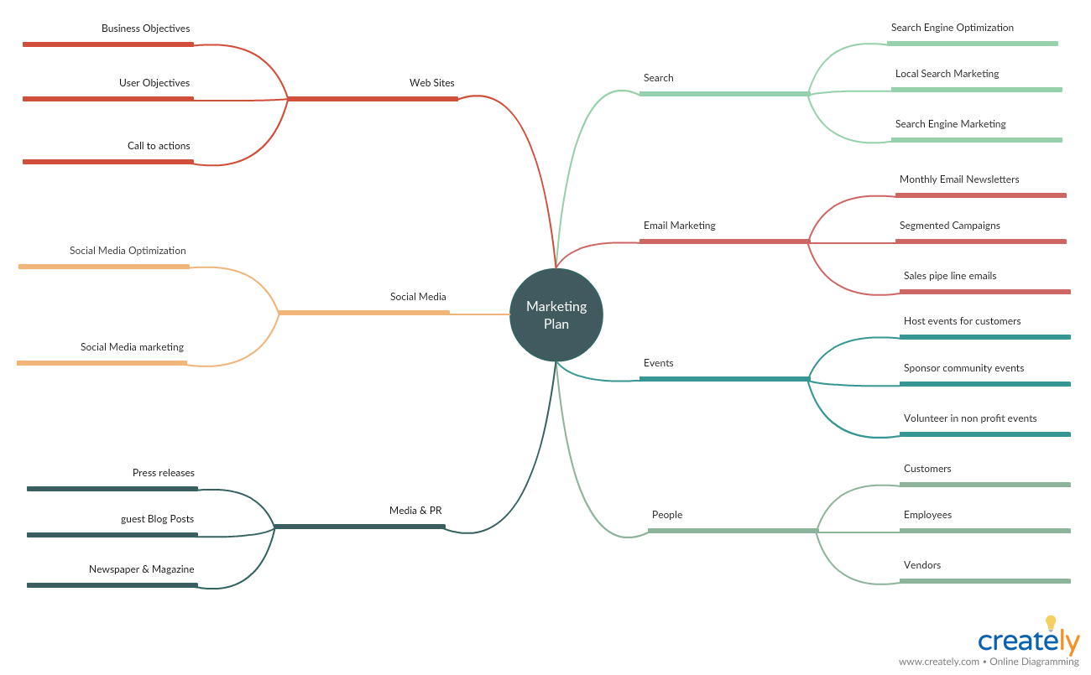

*Sales plan template

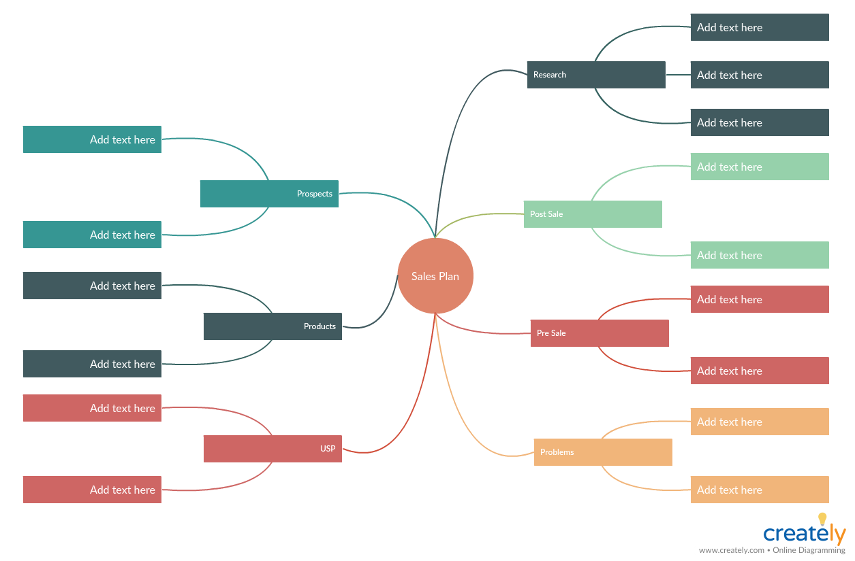

Organizational Structure and Management
< Highlight the key personnel involved in your business, and their roles and responsibilities.>

* You can use an organizational chart to map the hierarchy of your organizational structure
http://creately.com/creately-start?tempID=js4fz3151

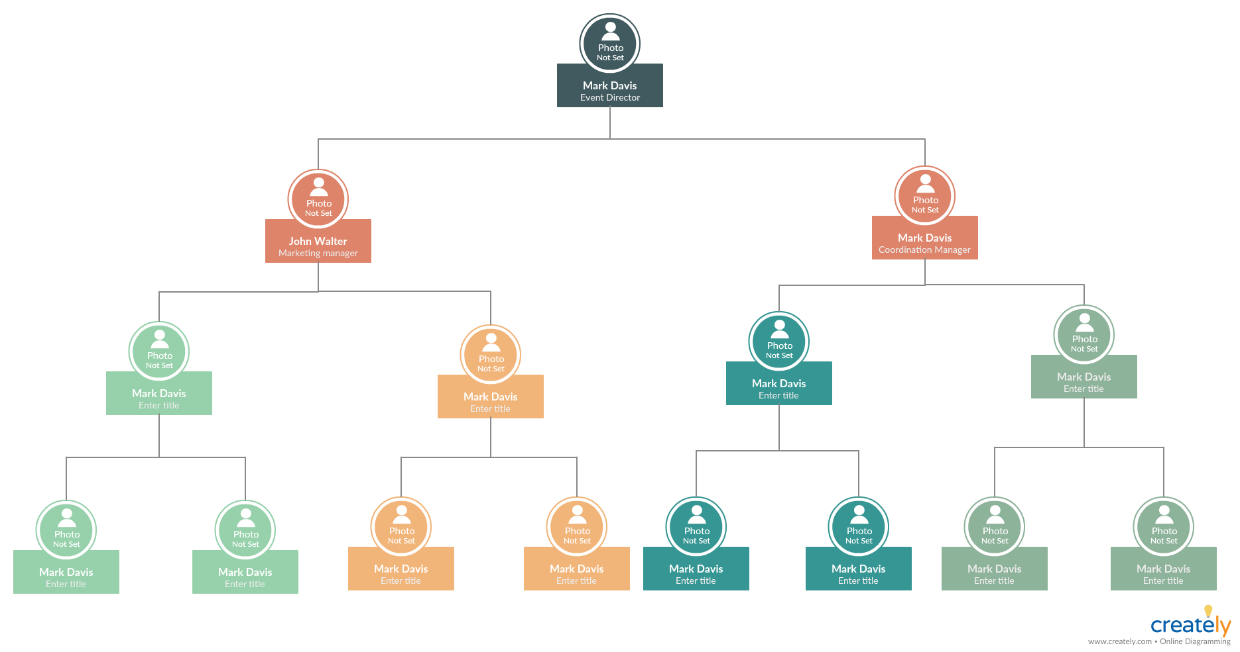

Products and Services
<Explain your products and services and how they can benefit your customers.>

* Map, design and describe your product strategy with this product canvas
http://creately.com/creately-start?tempID=js5ihun11
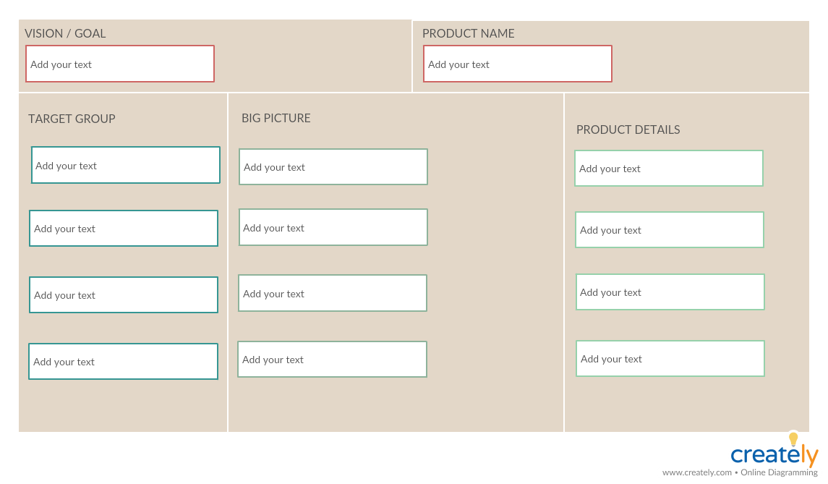

* Ensure that your product or service fits the requirements of your customers with this value proposition canvas
http://creately.com/creately-start?tempID=js4grn3s1

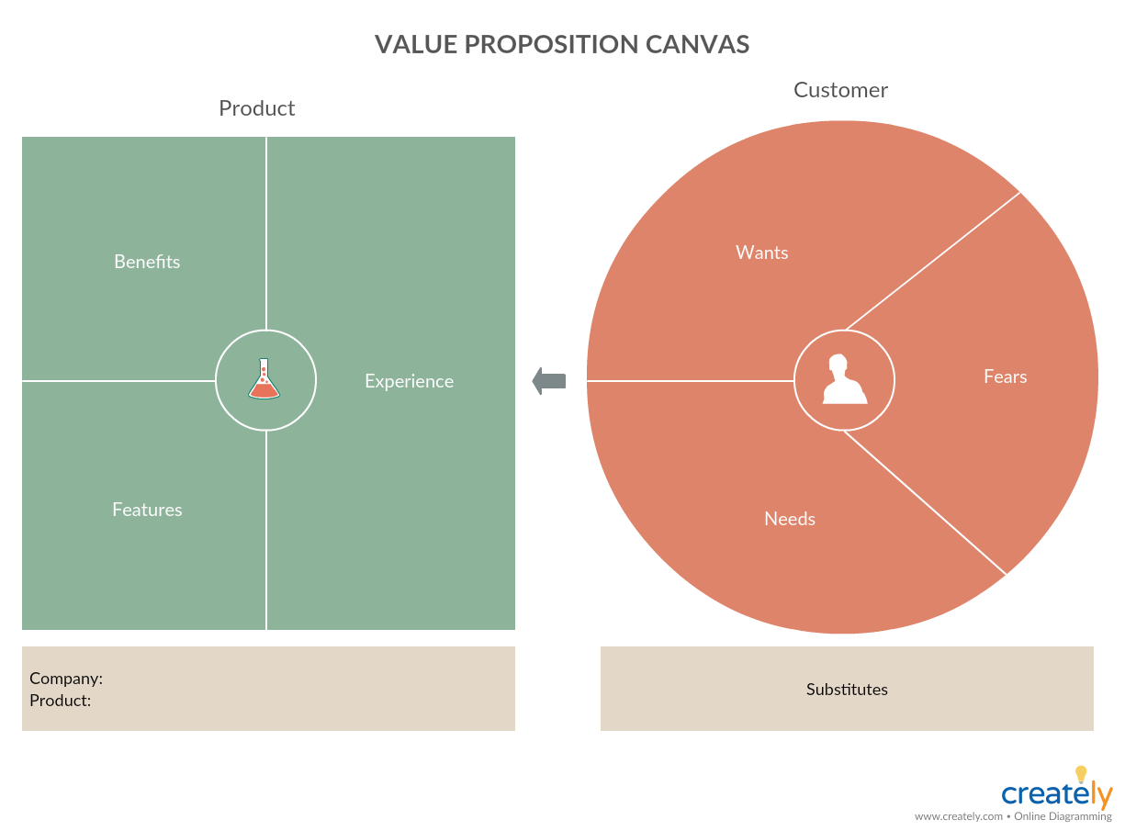

Financial Plan
<Provide relevant financial information, including historical data and financial projections showing the impact of your new product.>

*Use this mind map to organize your financial records. Add links to necessary resources on the relevant shape. Using the Creately Viewer, embed the always-updated diagram with navigable links on your website, intranet, wiki etc. for anyone to quickly access.
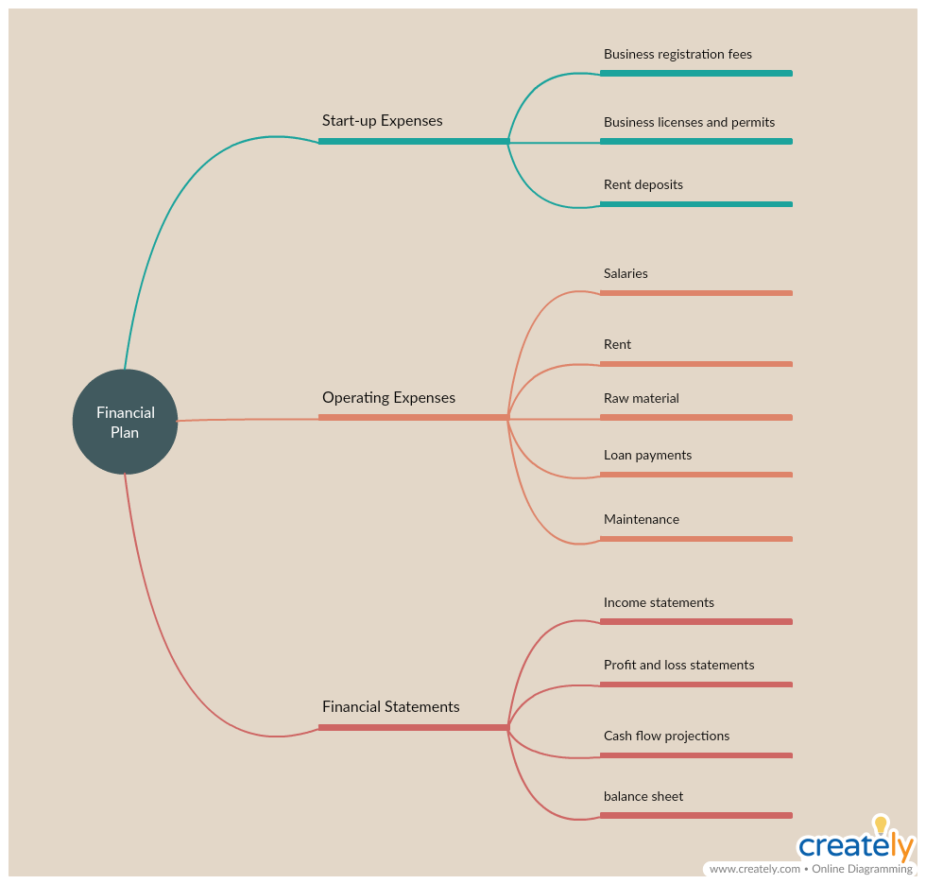
http://creately.com/creately-start?tempID=js4hn8kz1

